VERBAL DESCRIPTION  The following table shows the heights (in inches) of players on a high school basketball team and how many players are each height.  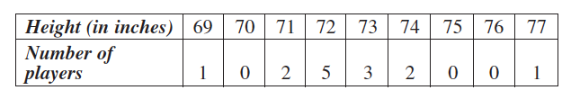 | TABLE OF VALUES
SCATTER PLOT | COMMUNICATION  - Describe the relationship between the player’s height and the number of players that are that height.  - Can you make a prediction based on the data?

