F

1. Write the equation of a parabola whose graph is shown.

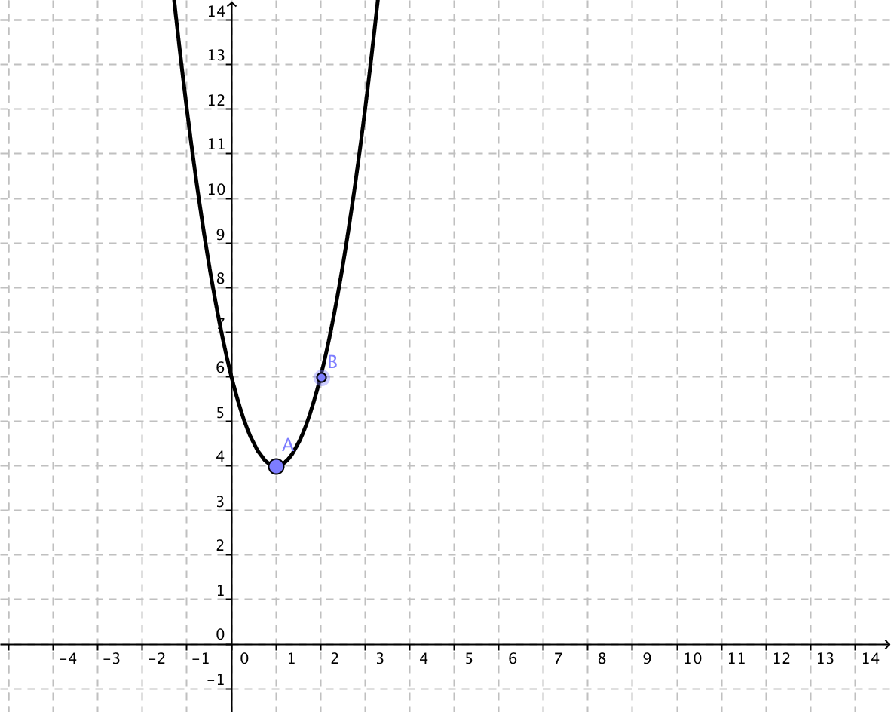

1. Sketch a graph of the equation 

Identify its vertex, intercepts and axis of symmetry.

U

The height y (in feet) of a punted football is given by:



where x is the horizontal distance in feet from the point at which the ball is punted.

1. How high was the ball when it was punted?
2. What is the maximum height of the ball?
3. How far was the ball punted?

|  |  |
| --- | --- |
| N1  Complete the link sheet for | |
| Possible rational zeros | Values |
| Constant Term = ______________  Leading coefficient = _________________  List all the POSSIBLE rational zeros: | 1. Find the zeros algebraically. 2. Find the y intercept algebraically. |
| Graph | Leading Coefficient Test |
|  | Degree = ___________  Leading coefficient = _________________  Describe the end behavior of f(x) |

C

Divide.

1. 
2. 

O

Graph the rational function:



Using the steps described in class.

N2

Solve: 

T

Find all the zeros (real and imaginary) of the function



Use the graphing calculator and synthetic division to help you factor.

I

1. Write (4 - 2i)+(3 - i) in standard form.
2. Write (4 - 2i)-(3 - i) in standard form.
3. Write (4 - 2i)(3 - i) in standard form.
4. Write (4-2i)/(3-i) in standard form.
5. What is the conjugate of 4 – 2i?

FUNCTION STATIONS FUNCTION STATIONS

RECORDING SHEET RECORDING SHEET

|  |  |  |  |  |
| --- | --- | --- | --- | --- |
| F |  |  | F |  |
| U |  |  | U |  |
| N1 |  | N1 |  |
| C |  | C |  |
| T |  | T |  |
| I |  | I |  |
| O |  | O |  |
| N2 |  | N2 |  |