Criterion E: Evaluation

<hide>
This form can be used to complete Criterion E: Evaluation.
This form uses the “Hidden Text” properties which can be found in the Font menus. The image below, as well as the Criterion E: Evaluation table are stored using hidden text. Use the paragraph icon
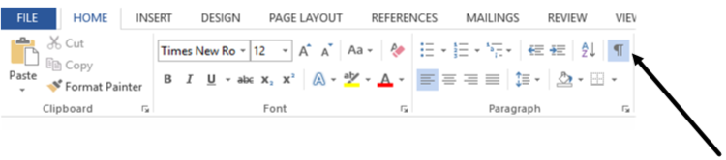
as shown to show and hide the hidden text. Before saving the document in PDF format hide all of the prompts using this button. Be sure to review you PDF to make sure all to the desired hidden text is hidden, and that all of the intended unhidden text is visible. Every effort has been made to make the hidden text color RED.

Directions:
- Read all of this document before updating it.
- Practice hiding the text using the icon shown above
- Unhide all of the text using the icon shown above.
- Update each of the prompts in this document – at least with a rough draft of answers to it can be easily completed after your client’s evaluation.

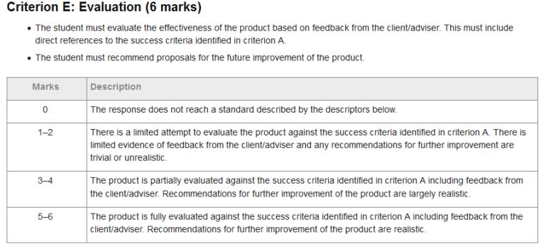
Prompt 1
Copy your success criterion in the box below:
.

Provide details about the feedback that you received from your client.
For each of the criterion that you have listed:
- How satisfied was the client that your solution met the success criteria?
- Did the client uncover any problems that you were not aware of?
- Did the client make recommendations about how the criteria could be improved?
</unhide>
Begin answer 1

<hide>
Prompt 2
Copy your success criterion in the box below:

For each of the success criteria listed, respond in complete sentences to the feedback you received from the client.:
- Are you and the client satisfied that your solution met the success criteria? Discuss any discrepancy between what was delivered and the clients expectations.
- Discuss how the client uncovered problems that you were not aware of. Did the user try to use the solution differently than it was designed for? Were there holes in your testing and debugging? How could this have been different?
- Did you get any new idea about how the criteria could be improved based on the clients actual experience? [The next section could be a place to go into details
- Do you agree or disagree with the client’s feed back? Why or why not – use full sentences.
</unhide>
Begin answer 2

Recommendations for Further Development

<hide>
Remember: Recommendations for further improvement of the product are realistic.

Prompt 3
What recommendations identified by the client should be included for future development?

</unhide>
Begin answer 3

<hide>
Prompt 4
What recommendations do you have to improve the functionality of the project? This could be from things you thought of during development, or testing, or talking to the client during the evaluation process. (or other sources of inspiration)

</unhide>
Begin answer 4

<hide>
Prompt 5
What improvements can be made to the way your client backs up data?
Does your IA rely on having data backed up the same way all other data is backed up locally?
Does your IA have data on a server, and rely on the server being backed up?
Can/does/should your IA make backup copies of the data at any point?
Is there a way for the client to recover the data as it was at some time period in the past?

</unhide>
Begin answer 5

<hide>
Prompt 6
Does you IA import or export data from/to other systems?
Is there a process that could be improved or added to the project to make sure that the data coming in or going out is correctly formatted?

</unhide>
Begin answer 6

<hide>
Prompt 7
How can user training or training materials be improved?

</unhide>
Begin answer 7

<hide>
Prompt 8
How can the user documentation that is part of your IA be improved

</unhide>
Begin answer 8

<hide>
Prompt 9
What other items/features/requirements would improve the IA project?

</unhide>
Begin answer 9

